IT SERVICE MANAGEMENT
PERFORMANCE IMPROVEMENT
Business Analysis • SQL Analytics • Power BI
Jurado Technologies
(simulated mid-sized organization for portfolio use)

Project role | Business / Data Analyst (portfolio simulation)
Analysis period | January 2025 – August 2026
Data volume | 500 employees • 12 technicians • 7 departments • 5,000 tickets
Deliverables | MySQL database & queries • Power BI dashboard • requirements • recommendations
Prepared as an end-to-end service desk analytics case study

1. Executive Summary
Jurado Technologies is modeled as a 500-employee organization supported by a 12-person IT service desk. The service desk has 5,000 historical support tickets spanning January 2025 through August 2026. Leadership needs a practical way to understand where support demand is coming from, why some tickets miss service-level targets, and which operational issues should be addressed first.
I built a relational MySQL database and a Power BI management dashboard to analyze ticket volume, resolution time, SLA compliance, user satisfaction, department demand, technician workload, and recurring technical issues. The analysis found that Network support is the clearest performance outlier: only 53.1% of Network tickets met SLA, compared with 67.1%–87.1% for the other major categories. VPN tickets performed poorly across every department, with SLA compliance ranging from 29.0% to 37.7%.
The data also shows a strong service-quality effect when SLA is missed. Tickets resolved within SLA averaged 8.04 hours and 4.35/5 satisfaction, while SLA-missed tickets averaged 31.12 hours and 2.25/5 satisfaction. Technician workload was relatively balanced, suggesting that routing, troubleshooting process, escalation, and issue complexity are stronger improvement opportunities than simply adding headcount.

1.1 Decision Questions
- Which departments and issue categories generate the most support demand?
- Where are SLA misses concentrated?
- Are poor SLA results primarily related to workload, staffing distribution, or issue type?
- How much does missing SLA affect resolution time and satisfaction?
- Which service desk changes should management prioritize first?

1.2 Key Results at a Glance
Metric | Result | Why It Matters
Total tickets | 5,000 | Provides the operational baseline.
Average resolution time | 13.94 hours | Shows overall service speed.
SLA compliance | 74.5% | About one in four tickets missed target.
Average satisfaction | 3.82 / 5 | Overall experience is acceptable, but SLA misses reduce satisfaction sharply.
Lowest-performing category | Network — 53.1% SLA | Primary operational improvement area.
VPN SLA by department | 29.0%–37.7% | Indicates a cross-department process/technology issue, not a single-department problem.

2. Business Context and Project Charter

2.1 Business Problem
The service desk records operational data, but management does not have a single view that connects ticket demand, SLA performance, resolution time, technician workload, and employee satisfaction. This makes it difficult to separate isolated incidents from recurring service problems and to decide where process changes will have the most impact.
The project was framed as an internal performance-improvement analysis: establish a service desk baseline, identify the strongest operational signals, and design a dashboard that could support a recurring management review.

2.2 Simulated Stakeholders
Stakeholder | Interest / Decision Need
Director of IT | Overall service performance, SLA risk, improvement priorities.
Service Desk Manager | Queue performance, technician workload, escalation and routing issues.
Support Leads | Recurring technical issues, category-specific bottlenecks, knowledge gaps.
Department Managers | Department demand and employee service experience.
Business / Data Analyst | Requirements, data validation, analysis, dashboarding, recommendations.

2.3 Scope
In scope:
- Relational data model for departments, employees, technicians, and support tickets.
- Data validation and SQL analysis of 5,000 support tickets.
- Power BI dashboard with KPI, category, department, technician, monthly, SLA, and VPN views.
- Business requirements, user stories, current/future process analysis, recommendations, and UAT.
Out of scope:
- Live integration with ServiceNow, Jira Service Management, or another production ticketing platform.
- Real employee PII or confidential company data.
- Production deployment, automated alerting, or role-based security configuration.
- Predictive machine learning or financial ROI calculations.

2.4 Assumptions and Data Limitations
This is a simulated case study using synthetic support data. The results are valid for the dataset and demonstrate the analysis workflow, but they should not be presented as outcomes from a real employer or production service desk. Recommendations and performance targets below are proposed scenario targets, not measured post-implementation results.

3. Business Requirements and User Stories

3.1 Business Requirements
ID | Requirement
BR-01 | Monitor total ticket volume and core service desk KPIs.
BR-02 | Measure average resolution time and identify slow-performing service areas.
BR-03 | Track SLA compliance and isolate where SLA misses occur.
BR-04 | Compare ticket demand by department and issue category.
BR-05 | Monitor monthly ticket trends and changes in demand over time.
BR-06 | Compare technician workload to identify meaningful workload imbalance.
BR-07 | Track satisfaction and evaluate its relationship with SLA performance.
BR-08 | Investigate recurring Network and VPN incidents as a priority problem area.
BR-09 | Support management comparison across department, category, technician, and time period.
BR-10 | Present underperforming areas clearly enough to support action-oriented review meetings.

3.2 User Stories
ID | Persona | User Story
US-01 | IT Manager | I want to see ticket volume and SLA compliance so I can judge overall service desk performance.
US-02 | IT Manager | I want to identify the lowest-performing issue categories so I can prioritize improvement work.
US-03 | Service Desk Manager | I want to compare technician workloads so I can evaluate queue distribution.
US-04 | Support Lead | I want to isolate recurring Network and VPN problems so I can improve troubleshooting and escalation.
US-05 | Department Manager | I want to compare department ticket demand so I understand where support demand is concentrated.
US-06 | Service Desk Manager | I want monthly trends so I can distinguish recurring issues from temporary spikes.
US-07 | IT Manager | I want to compare SLA results with satisfaction so I can connect operational performance to user experience.

3.3 Requirements Traceability
Requirement | Dashboard / Analysis Evidence | Validation
BR-01 | KPI cards: Total Tickets, Avg Resolution, SLA Compliance, Avg Satisfaction | UAT-01 / UAT-02
BR-03 | SLA Performance donut; SLA Compliance by Issue Category | UAT-02 / UAT-03
BR-04 | Tickets by Department; Tickets by Issue Category | UAT-04
BR-05 | Monthly Ticket Trend | UAT-06
BR-06 | Technician Workload | UAT-07
BR-08 | VPN SLA Performance by Department; Network category analysis | UAT-03 / UAT-08

4. Technical Solution

4.1 Data Model
The MySQL database uses four related tables. Departments provides organizational reference data; Employees links staff to departments; Technicians stores support-role attributes; and Support Tickets contains the transaction-level service records. Power BI imports the same tables and uses active one-to-many relationships to support filtering from Departments and Technicians into Support Tickets.
Table | Purpose | Key Fields
Departments | Department reference data | department_id, department_name
Employees | Employee and organization data | employee_id, department_id, job_title, location, employment_status
Technicians | Support staff and specialization | technician_id, employee_id, support_level, specialty
Support Tickets | 5,000 service records | ticket_id, employee_id, technician_id, issue_category, issue_subcategory, priority, dates, resolution_time_hours, sla_met, satisfaction_score

4.2 Representative SQL Analysis
A representative query used to compare service performance by issue category:
SELECT
issue_category,
COUNT(*) AS total_tickets,
ROUND(AVG(resolution_time_hours), 2) AS avg_resolution_hours,
ROUND(AVG(sla_met) * 100, 1) AS sla_compliance_pct,
ROUND(AVG(satisfaction_score), 2) AS avg_satisfaction
FROM support_tickets
GROUP BY issue_category
ORDER BY avg_satisfaction ASC;

4.3 Power BI Measures
Measure | DAX Logic
Total Tickets | COUNTROWS('Support Tickets')
Avg Resolution Hours | ROUND(AVERAGE('Support Tickets'[resolution_time_hours]), 2)
SLA Compliance | SLA-met ticket count ÷ total ticket count
Avg Satisfaction | ROUND(AVERAGE('Support Tickets'[satisfaction_score]), 2)
VPN SLA Compliance | SLA Compliance filtered to issue_subcategory = 'VPN Connection'

5. Analysis Findings

5.1 Service Performance by Issue Category
Category | Tickets | Avg Resolution | SLA Compliance | Avg Satisfaction
Network | 1,012 | 18.12 hrs | 53.1% | 3.36
Hardware | 695 | 18.75 hrs | 67.1% | 3.71
Software | 1,153 | 14.81 hrs | 78.2% | 3.89
Security | 494 | 8.13 hrs | 79.1% | 3.89
Printing | 430 | 14.12 hrs | 85.6% | 4.07
Account Access | 1,216 | 9.18 hrs | 87.1% | 4.07

Interpretation: Network support is the strongest performance outlier. It combines high ticket volume with the lowest SLA compliance and lowest average satisfaction. Hardware has a slightly longer average resolution time, but its SLA performance is materially better than Network.

5.2 SLA Misses and User Experience
SLA Status | Tickets | Avg Resolution | Avg Satisfaction
SLA Met | 3,723 | 8.04 hrs | 4.35 / 5
SLA Missed | 1,277 | 31.12 hrs | 2.25 / 5

Interpretation: A missed SLA is associated with nearly four times the resolution time and a 2.10-point drop in satisfaction. This makes SLA improvement a service-quality issue, not just a compliance metric.

5.3 Technician Workload
Ticket assignment ranged from 355 to 500 tickets across the 12 technicians, with an average of approximately 417 tickets per technician. The spread is noticeable but not extreme. The weak Network/VPN results therefore cannot be explained by one technician carrying a disproportionate share of the entire queue.

5.4 VPN Performance by Department
Department | VPN SLA Compliance
Marketing | 29.0%
Customer Service | 30.4%
Finance | 35.4%
Operations | 36.5%
Information Technology | 36.7%
Human Resources | 37.0%
Sales | 37.7%

Interpretation: VPN performance is weak across every department. Because the problem is not isolated to one business unit, the more likely improvement areas are shared troubleshooting steps, routing, escalation, access dependencies, or underlying network/VPN reliability.

5.5 Monthly Volume
Lower-volume months averaged 231.8 tickets and 75.1% SLA compliance. High-volume months averaged 272.2 tickets and 73.9% SLA compliance. Higher demand corresponds with a modest SLA decline, but the difference is much smaller than the performance gap between issue categories. This supports treating issue type and process complexity as primary hypotheses.

6. Power BI Management Dashboard
The dashboard was designed for a management review rather than for raw data exploration. The top row establishes the operating baseline; the middle section shows demand and trends; and the lower section focuses on operational risk and workload. Network is highlighted in red in the SLA chart to direct attention to the most significant outlier.
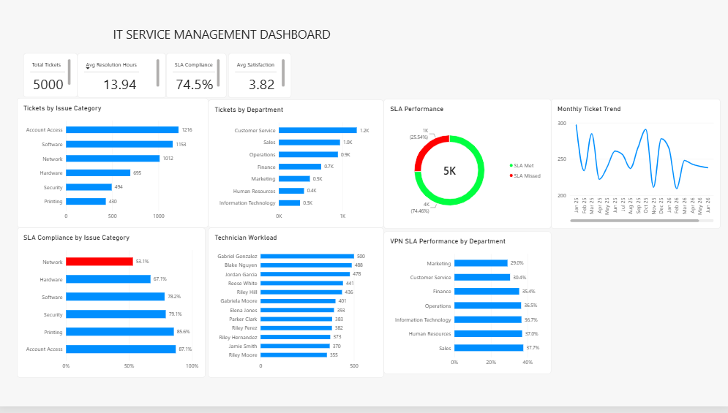
Figure 1. IT Service Management Power BI dashboard built from the MySQL service desk dataset.

6.1 Dashboard Views
- KPI cards: 5,000 tickets, 13.94 average resolution hours, 74.5% SLA compliance, 3.82/5 satisfaction.
- Demand: Tickets by Issue Category and Tickets by Department.
- Trend: Monthly Ticket Trend with chronological month sorting.
- Service quality: SLA Met vs. SLA Missed donut.
- Risk: SLA Compliance by Issue Category with Network emphasized.
- Capacity: Technician Workload ranking.
- Root-cause focus: VPN SLA Performance by Department.

7. Current-State and Future-State Process

7.1 AS-IS Service Desk Workflow
- Employee reports an IT issue through an available support channel.
- A ticket is created and categorized.
- The ticket is assigned to a technician.
- The technician investigates and resolves the issue, escalating when necessary.
- Resolution time, SLA status, and satisfaction are captured after service completion.
- Management reviews performance primarily after closure, making recurring bottlenecks harder to identify early.
Observed weakness: the workflow captures useful data, but the management process is reactive. There is no explicit step for identifying SLA risk while a ticket is still open or for routing recurring Network/VPN work based on specialty and known troubleshooting paths.

7.2 TO-BE Service Desk Workflow
- Employee reports an issue and the ticket is categorized using standardized issue/subcategory values.
- Network/VPN tickets are identified at intake and routed using specialty and support-level rules.
- Open tickets are monitored against SLA target time, with attention to tickets approaching breach.
- Technicians use a shared knowledge base for recurring VPN, DNS, Wi-Fi, access, and connectivity issues.
- Escalation occurs through a defined path when Tier 1 troubleshooting does not resolve the issue.
- Dashboard metrics refresh for management review of volume, SLA, resolution time, and satisfaction.
- Monthly review compares the same category metrics to determine whether the changes are improving performance.

7.3 Recommendations and Proposed 90-Day Targets
The targets below are proposed scenario goals for a production pilot; they are not outcomes already achieved by this project.
Priority | Recommendation | Owner (simulated) | Proposed Measure / Target
High | Standardize Network/VPN troubleshooting and create a searchable knowledge base. | Support Lead | Network SLA: 53.1% → at least 70% within 90 days.
High | Introduce SLA-risk queue monitoring for tickets approaching breach. | Service Desk Manager | Reduce SLA-missed ticket average resolution from 31.12 hrs toward <24 hrs.
High | Route complex Network tickets using technician specialty/support level. | Service Desk Manager | Increase first-assignment quality; reduce avoidable reassignment/escalation delay.
Medium | Review VPN access dependencies, escalation path, and common failure modes. | Network Support Lead | Raise departmental VPN SLA from 29.0%–37.7% toward at least 55%.
Medium | Use a recurring monthly dashboard review with owners for underperforming metrics. | Director of IT | Track Network SLA, VPN SLA, missed-ticket resolution time, and satisfaction month over month.

8. Validation, UAT, and Production Considerations

8.1 User Acceptance Tests
ID | Test | Expected Result | Status
UAT-01 | Open dashboard with no filters | Total Tickets = 5,000 | Pass
UAT-02 | Review SLA KPI | SLA Compliance ≈ 74.5% | Pass
UAT-03 | Review issue-category SLA chart | Network ≈ 53.1% and is lowest category | Pass
UAT-04 | Review department demand | Department totals vary; Customer Service is highest | Pass
UAT-05 | Review SLA donut | SLA Met / Missed ≈ 74.5% / 25.5% | Pass
UAT-06 | Review monthly trend | Month labels sort chronologically from 2025 through 2026 | Pass
UAT-07 | Review technician workload | Workload ranges approximately 355–500 tickets | Pass
UAT-08 | Review VPN chart | All department VPN SLA values remain below 40% | Pass

8.2 Production Considerations
- Replace CSV/manual imports with a scheduled connection to the production ticketing platform or reporting database.
- Define an authoritative SLA policy by priority, issue type, and business hours before deploying automated alerts.
- Implement row-level security if department managers should only see their own business unit.
- Create a refresh schedule and data-quality checks for missing technician IDs, invalid categories, and unresolved timestamps.
- Add drill-through pages for individual categories, technicians, and recurring subcategories once the management summary is adopted.

9. Skills Demonstrated and Portfolio Use

9.1 Technical Skills
- MySQL relational database design and foreign-key relationships
- SQL joins, aggregation, CASE logic, CTEs, date functions, and KPI calculations
- CSV import and data validation
- Power BI relationships and semantic modeling
- DAX measures and calculated columns
- Dashboard design, sorting, labeling, conditional emphasis, and business storytelling

9.2 Business Analysis Skills
- Business problem framing and stakeholder needs
- Business requirements and user stories
- Requirements traceability
- AS-IS / TO-BE process analysis
- Root-cause hypothesis development
- Action-oriented recommendations and proposed success measures
- User acceptance testing

9.3 Interview-Ready Project Summary
“I built an end-to-end IT service management analytics project using MySQL and Power BI. I modeled a 500-employee service desk environment with 5,000 tickets, designed the relational database, wrote SQL to analyze SLA and resolution performance, and created a management dashboard with DAX measures. The main finding was that Network and VPN tickets were the strongest service bottleneck. Network SLA compliance was only 53.1%, and SLA-missed tickets averaged 31.12 hours to resolve with much lower satisfaction. I used those findings to propose routing, knowledge-base, SLA-monitoring, and escalation improvements, then documented requirements and UAT to show how the solution would be implemented in a real environment.”

10. Project Deliverables
Deliverable | Purpose
MySQL database / SQL scripts | Reproducible relational model, data loading, validation, and analysis.
Power BI .pbix dashboard | Interactive management view of service desk performance.
Project documentation | Business context, requirements, findings, process analysis, recommendations, and UAT.
Portfolio summary / resume bullets | Concise evidence of technical and business-analysis skills for job applications.

